Appendix 4 Sensitivity analysis of consumption response to government spending shock

In this annex we discuss the sensitivity analysis of the consumption response to government spending shock. In particular we are interested in the detailed mapping of the model parameterisations that drive towards a positive or a negative response in the short term.
We apply the same Monte Carlo sample used for the acceptability analysis shown in Appendix 2 and solve the model for each MC realisation. This allows to obtain the prior uncertainty distribution of the first quarter response of 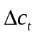versus 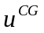, that we report in Figure A4.1. In Figure A4.1 it can be seen that under the prior assumptions implied by the model structure and prior distributions, the model puts a somewhat larger prior probability for a negative response (the mode of the histogram is on the negative part). Nonetheless, the prior probability of a positive response is also significantly larger than zero. This is the result of the combination of the prior distribution for liquidity constrained households, which is evenly and neutrally distributed between negative and positive responses, and the prior distribution for Ricardian households, which is always negative.

In order to understand more clearly the conditions under which a positive response is more likely than a negative one, we perform a detailed sensitivity analysis. In particular we apply global sensitivity analysis techniques to map the function

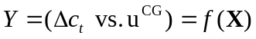

where X is the vector of model parameters. The details about the estimation method can be found in Ratto et al. (2007) and Ratto (2008). The approach we adopt is in practice the estimation of a non-parametric regression model on the MC sample used for Figure A4.1:

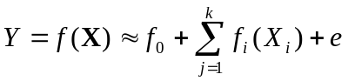

where 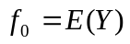 is the mean of Y, e is the residual of the non parametric regression model and 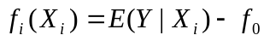 are the non-parametric regression terms for each model parameter, i.e. the conditional expectation of Y, given 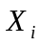. The quantity 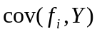 is the so-called correlation ratio or non-parametric R-squared and provides the portion of variance of Y that is explained by each model parameter . Hence, the 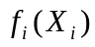 terms provide the best least-squares predictors of Y, based on univariate functions of single model parameters. This MC approach to sensitivity is typical in global sensitivity analysis (see e.g. Saltelli et al., 2004) and detects the effect of each model parameter by varying all the other parameters at the same time. This provides an extremely powerful measure of sensitivity, since a significant pattern in terms of conditional expectations 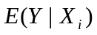 tells that changing the value of implies a shift in the mean of Y, i.e. tells that one is able to drive the sign of Y whatever the values of the remaining model parameters. This contrasts with other sensitivity analysis typically found in the literature, which are performed moving one parameter at a time around a base point in the prior space. This latter approach may be heavily prone to the base point around which the analysis is performed.

In Figure A4.4 we show the plots of for the most important parameters driving the consumption response (continuous lines). Dotted lines show the width of the 90% confidence bands of the estimated non-parametric curves, that allow to appreciate the significance of the functions. The values in the y –axis tell exactly by how much one can expect to change the value of the consumption response with respect to its prior mean values by varying each single parameter. These plots allow a rather interesting and informative discussion.

- most parameters display a rather non-linear pattern, with rather sharp negative or positive peaks towards the bounds of their prior distributions;
- labour and wage adjustment cost coefficients 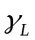 display a decreasing pattern: when they tend to zero, the patterns show a rather non-linear and peaked positive values while increasing adjustment costs tend to drive smoothly towards a negative consumption response;
- price adjustment cost coefficient 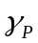 has an opposite behaviour and increasing drives a positive consumption response, while towards zero implies a sharp negative tendency for this response;
- large values of 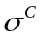 and slc also drive a positive response of consumption;
- the patterns for 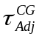 and 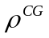 suggest that the more persistent is G spending, the more negative will be the consumption response;
- the shape for monetary policy parameters suggests that the more the monetary authority is active, the smaller (i.e. more negative) will be the consumption response: in fact positive C response is associate to high 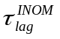 values and small 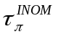, 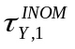 and 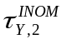
- the transfer rule also affects the consumption response: the larger the response to unemployment, the more negative tends to be the consumption response.

One would also expect an effect of 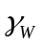. This is extremely non-linear and the simple smoothing technique on a single Monte Carlo sample does not allow to visualize the effect of . In Figure A4.2 we show the prior uncertainty distribution of the consumption response when has been fixed at zero. Now the aggregate consumption is evenly distributed around zero, implying the probability of a positive response versus government spending is increased. This is due to the much more skewed distribution of liquidity constrained households towards positive values. Fixing contemporaneously 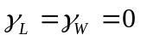 (Fig. A4.3) as in Gali et al. (2007), we get that the prior distribution of the response of aggregate consumption versus government spending is almost entirely on positive values.

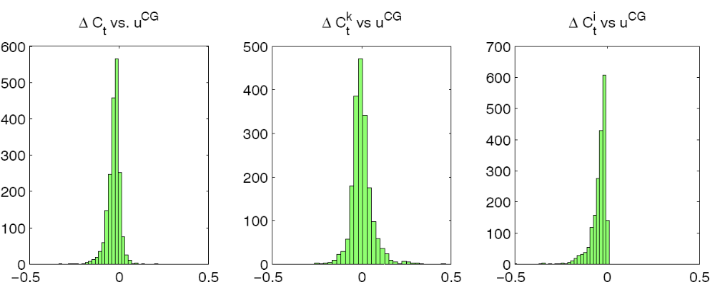

FIGURE A4.1 Prior uncertainty distribution of the response of aggregate consumption growth to government spending shock

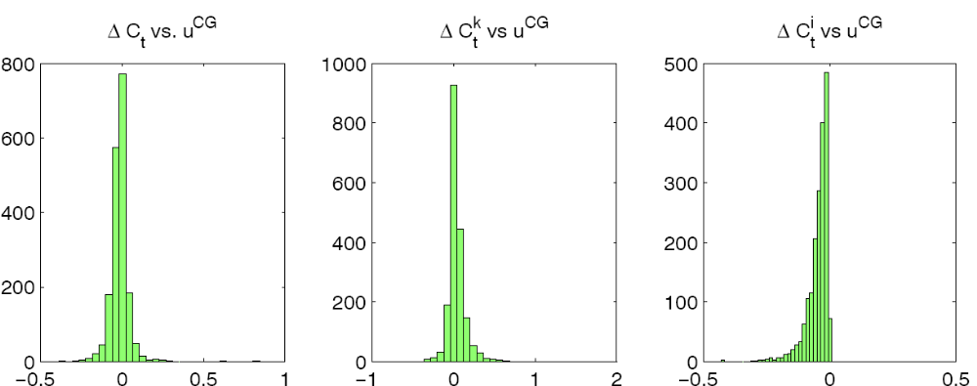

FIGURE A4.2 Prior uncertainty distribution of the response of aggregate consumption growth to government spending shock when 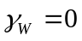.

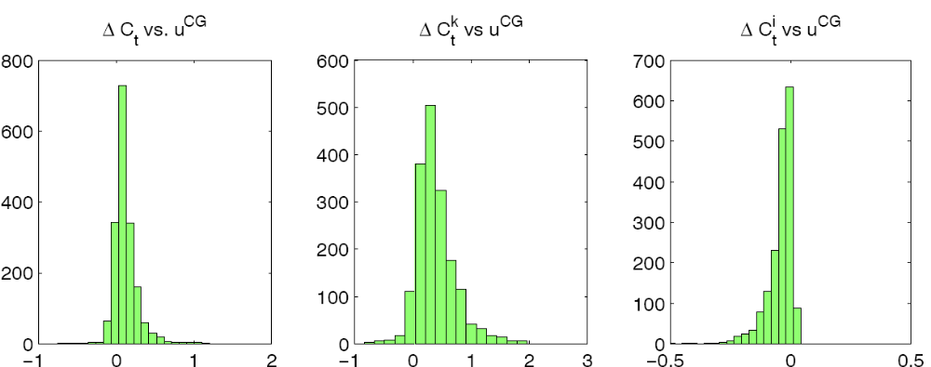

FIGURE A4.3 Prior uncertainty distribution of the response of aggregate consumption growth to government spending shock when .

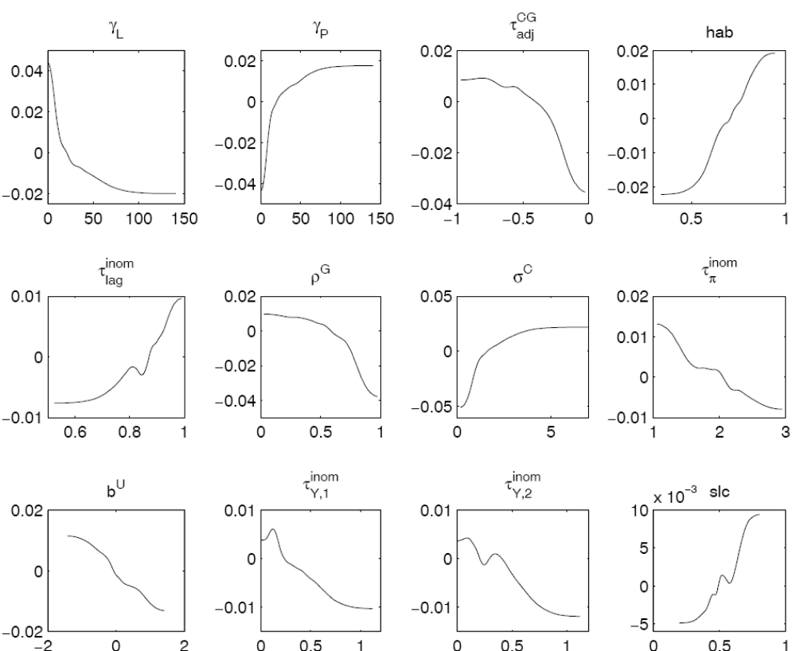

FIGURE A4.4. Sensitivity analysis of the response of aggregate consumption to government spending shock.

Footnote for Figure A4.4:
Note: Non-parametric regression of the prior sample of the first quarter response of vs.. Plots show the shape of the non-parametric curves of the most relevant factors driving the consumption response.

References

Ratto, M., 2008. Analysing DSGE models with Global Sensitivity Analysis, Computational Economics 31, 115-139.
Ratto, M., Pagano A., Young, P., 2007. State Dependent Parameter metamodelling and sensitivity analysis. Computer Physics Communications 177, 863-876.
Saltelli, A., Tarantola, S., Campolongo, F., Ratto, M., 2004. Sensitivity Analysis in Practice: A Guide to Assessing Scientific Models. John Wiley and Sons.

